|  |  |  |
| --- | --- | --- |
| Unit 8 Written quiz | Name: __Chhorn Sotheavann___ | **Total Score** |
| Date: ____7 March 2023______ | ______ /50 points |

A CD icon.tiff Listen to Mike talk about his weekend. Circle *True* or *False* for each sentence.

1. Mike went to a party at his neighbors’ apartment Saturday night. **True False**

2. Mike had to get up early Sunday morning. **True False**

3. Mike nicely asked his neighbor to turn the music down. **True False**

4. After talking to his neighbor, Mike decided that he shouldn’t have said anything. **True False**

**A** _______ /8 points (2 points each)

B Circle the correct word to complete each sentence.

1. My main **motivation / confidence / empathy** in life is to make myself and my friends happy.

2. You shouldn’t set goals for yourself that you can’t achieve. You need to be more **decisive / impulsive / realistic**.

3. If I have a problem, I always talk with my best friend. I know she’ll be **ashamed / sympathetic / jealous** and give

me good advice.

4. My brother has a lot of **self-awareness / honesty / determination**. If he decides he wants to do something,

nothing will stop him from doing it.

**B** _______ /4 points (1 point each)

C You emailed a friend a week ago, and she did not reply. Speculate about what happened. Rewrite the sentences using past modals.

1. It’s possible she went on vacation. (may) ___She may have gone on vacation._________________________

2. Maybe she didn’t receive it. (might) ____She might not have received it.______________________________

3. It’s possible she was sick. (could) ______She could have been sick._________________________________

4. Maybe I didn’t get her response. (might) _____I might not have received her response.__________________

5. It’s not possible she ignored it. (could) ______She could not have ignored it.__________________________

6. I bet I had the wrong email address. (must) _____I must have had the wrong email address.______________

**C** _______ /12 points (2 points each)

D Read the situation below. Write sentences about how these people could have reacted differently.   
Use the words in parentheses and past modals.

*Yesterday, Dan bought an expensive car without talking to his wife, Regina. Regina got upset and yelled at him.   
Dan did not respond. He got up and left the house.*

*Dan could have talked with her about it first.*

**Example:**(Dan / talk / with her about it first) _______________________________________________________

1. (Dan / not / leave the house) ______Dan might not have left the house.________________________________

2. (Someone else / think / before saying anything) __Someone else could have thought before saying anything.__

3. (Regina / stay / calm) ______Regina could have stayed calm.________________________________________

4. (Some people / not have / an argument) ________Some people might not have had an argument.___________

5. (Regina / not yell / at Dan) ______Regina could not have yelled at Dan.________________________________

**D** _______ /10 points (2 points each)

E Complete the conversations with expressions to share experiences. Use the words in parentheses.

1. ***A***I had dinner with this friend yesterday who didn’t pay his share of the bill. Like, I had to add

more money so the waiter got a tip!

***B***____Similar thing happened to me________ (similar). I told my friend that he was taking advantage of me,

and he got really angry.

2. ***A***I was sitting next to these people on the bus yesterday who were breaking up. They were having this really

emotional conversation.

***B***____Doesn't that kind of thing happen? _____ (happen). Don’t people realize that they shouldn’t talk about

things like that in public places?

3. ***A***I lent a friend my favorite book once, but he never gave it back.

***B***_____That reminds me of _______________ (reminds) my roommate in college. She sometimes borrowed

my clothes without even asking me!

4. ***A***Someone lied to me once, but he wouldn’t admit that he had done anything wrong.

***B***______Sounds like________________________ (like) my friend Sarah. She never apologizes for anything.

**E** _______ /8 points (2 points each)

F Read the article. Then read the statements and circle (a) *True*, (b) *False*, or (c) *Doesn’t say*.

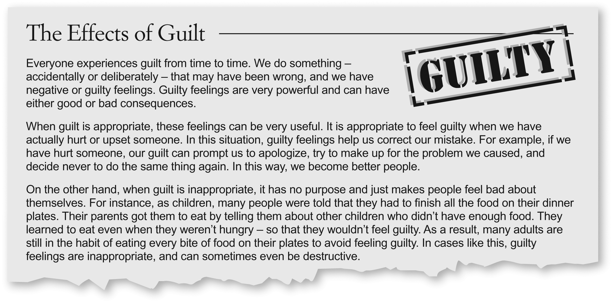

1. Guilt always has a negative effect on a person.

a. True b. False c. Doesn’t say

2. Guilt can help people learn from their past actions.

a. True b. False c. Doesn’t say

3. Parents usually have guilty feelings.

a. True b. False c. Doesn’t say

4. Some people overeat because they feel guilty.

a. True b. False c. Doesn’t say

**F** _______ /8 points (2 points each)